Auto Temperature Detector for Entrance For Covid

Abstract

COVID 19 has made a huge impact on the society, the new restriction has been imposed as in the number of users allowed in a particular room in offices, shops, etc. to maintain social distancing, along with social distancing regular temperature check at entrances of malls, the office is mandatory. In this project we stimulate a room where such necessary precautions are taken, we make use of a laser diode and receiver to detect the entrance of a person, when the project detect entrance it will check the temperature of the person if the temperature is less than the set temperature the person is allowed entry otherwise the entry is denied. only a pre-determined number of people are allowed in the room. The allowed temperature, the number of people allowed in the room as well as the number of people actively present in the room can be set/viewed using a Bluetooth App.

INTRODUCTION TO EMBEDDED SYSTEMS

What is embedded system?
An Embedded System is a combination of computer hardware and software, and perhaps additional mechanical or other parts, designed to perform a specific function. An embedded system is a microcontroller-based, software driven, reliable, real-time control system, autonomous, or human or network interactive, operating on diverse physical variables and in diverse environments and sold into a competitive and cost conscious market.
An embedded system is not a computer system that is used primarily for processing, not a software system on PC or UNIX, not a traditional business or scientific application. High-end embedded & lower end embedded systems. High-end embedded system - Generally 32, 64 Bit Controllers used with OS. Examples Personal Digital Assistant and Mobile phones etc .Lower end embedded systems - Generally 8,16 Bit Controllers used with an minimal operating systems and hardware layout designed for the specific purpose.

SYSTEM DESIGN CALLS:

Figure 2(a): Embedded system design calls

EMBEDDED SYSTEM DESIGN CYCLE

Figure:2(b) “V Diagram”

Characteristics of Embedded System
- An embedded system is any computer system hidden inside a product other than a computer.
- They will encounter a number of difficulties when writing embedded system software in addition to those we encounter when we write applications.
  - Throughput – Our system may need to handle a lot of data in a short period of time.
  - Response–Our system may need to react to events quickly
  - Testability–Setting up equipment to test embedded software can be difficult.
  - Debugability–Without a screen or a keyboard, finding out what the software is doing wrong (other than not working) is a troublesome problem.
  - Reliability – embedded systems must be able to handle any situation without human intervention.
  - Memory space – Memory is limited on embedded systems, and you must make the software and the data fit into whatever memory exists.
  - Program installation – you will need special tools to get your software into embedded systems.
  - Power consumption – Portable systems must run on battery power, and the software in these systems must conserve power.
  - Processor hogs – computing that requires large amounts of CPU time can complicate the response problem.
  - Cost – Reducing the cost of the hardware is a concern in many embedded system projects; software often operates on hardware that is barely adequate for the job.
- Embedded systems have a microprocessor/ microcontroller and a memory. Some have a serial port or a network connection. They usually do not have keyboards, screens or disk drives.

APPLICATIONS
- Military and aerospace embedded software applications
- Communication Applications
- Industrial automation and process control software
- Mastering the complexity of applications.
- Reduction of product design time.
- Real time processing of ever increasing amounts of data.
- Intelligent, autonomous sensors.

CLASSIFICATION
- Real Time Systems.
- RTS is one which has to respond to events within a specified deadline.
- A right answer after the dead line is a wrong answer.

RTS CLASSIFICATION
- Hard Real Time Systems
- Soft Real Time System

HARD REAL TIME SYSTEM
- "Hard" real-time systems have very narrow response time.
- Example: Nuclear power system, Cardiac pacemaker.

SOFT REAL TIME SYSTEM
- "Soft" real-time systems have reduced constrains on "lateness" but still must operate very quickly and repeatable.
- Example: Railway reservation system – takes a few extra seconds the data remains valid.

3. PROJECT BLOCK DIAGRAM

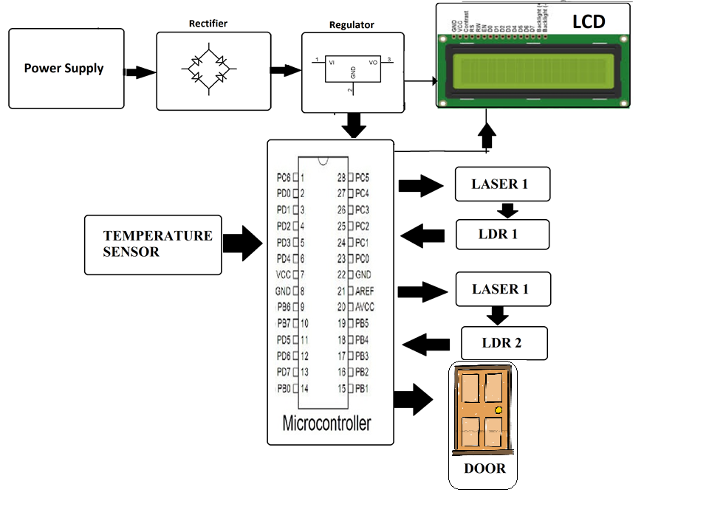

HARDWARE REQUIREMENTS

HARDWARE COMPONENT:
- Atmega 328p Microcontroller

- Non Contact Temperature Sensor

- Bluetooth

- DC Motor

- LCD Display IC

- Vtg Regulator IC

- Resistors

- Capacitors

- Transistors

- Cables and Connectors

- Diodes

- PCB and Breadboards

- LED

- Transformer/Adapter

- Push Buttons

- Buzzer

- IC

- IC Sockets

VOLTAGE REGULATOR 7805
Features
• Output Current up to 1A.
• Output Voltages of 5, 6, 8, 9, 10, 12, 15, 18, 24V.
• Thermal Overload Protection.
• Short Circuit Protection.
• Output Transistor Safe Operating Area Protection.
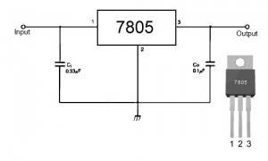
Description
The LM78XX/LM78XXA series of three-terminal positive regulators are available in the TO-220/D-PAK package and with several fixed output voltages, making them useful in a Wide range of applications. Each type employs internal current limiting, thermal shutdown and safe operating area protection, making it essentially indestructible. If adequate heat sinking is provided, they can deliver over 1A output Current. Although designed primarily as fixed voltage regulators, these devices can be used with external components to obtain adjustable voltages and currents.

Internal Block Diagram
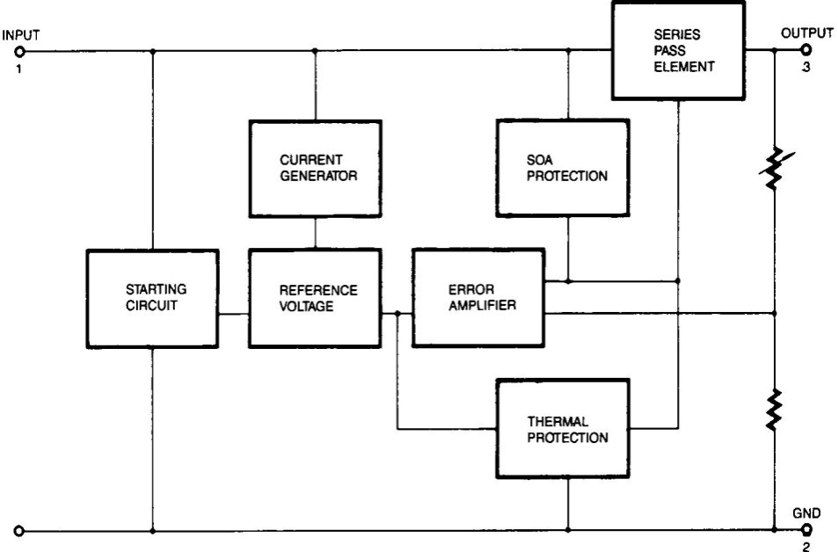

FIG 4.2(a): BLOCK DIAGRAM OF VOLTAGE REGULATOR
Absolute Maximum Ratings
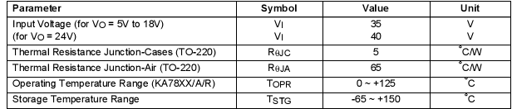
TABLE 4.2(b): RATINGS OF THE VOLTAGE REGULATOR

RECTIFIER
A rectifier is an electrical device that converts alternating current (AC), which periodically reverses direction, to direct current (DC), current that flows in only one direction, a process known as rectification. Rectifiers have many uses including as components of power supplies and as detectors of radio signals. Rectifiers may be made of solid state diodes, vacuum tube diodes, mercury arc valves, and other components. The output from the transformer is fed to the rectifier. It converts A.C. into pulsating D.C. The rectifier may be a half wave or a full wave rectifier. In this project, a bridge rectifier is used because of its merits like good stability and full wave rectification. In positive half cycle only two diodes (1 set of parallel diodes) will conduct, in negative half cycle remaining two diodes will conduct and they will conduct only in forward bias only.

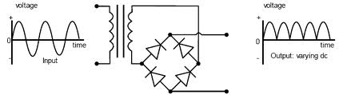

FILTER

Capacitive filter is used in this project. It removes the ripples from the output of rectifier and smoothens the D.C. Output received from this filter is constant until the mains voltage and load is maintained constant. However, if either of the two is varied, D.C. voltage received at this point changes. Therefore a regulator is applied at the output stage.
The simple capacitor filter is the most basic type of power supply filter. The use of this filter is very limited. It is sometimes used on extremely high-voltage, low-current power supplies for cathode-ray and similar electron tubes that require very little load current from the supply. This filter is also used in circuits where the power-supply ripple frequency is not critical and can be relatively high. Below figure can show how the capacitor charges and discharges.
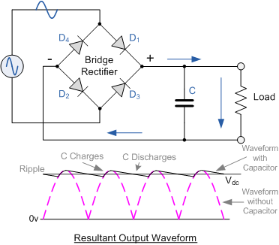

ATMEGA328

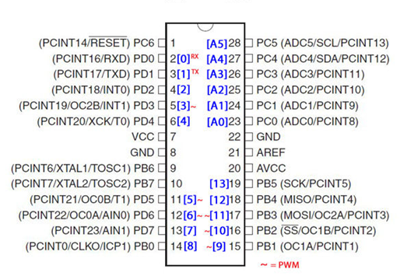

Introduction:

The Atmel ATmega328P is a 32K 8-bit microcontroller based on the AVR architecture. Many instructions are executed in a single clock cycle providing a throughput of almost 20 MIPS at 20MHz. The ATMEGA328-PU comes in an PDIP 28 pin package and is suitable for use on our 28 pin AVR Development Board.
The computer on one hand is designed to perform all the general purpose tasks on a single machine like you can use a computer to run a software to perform calculations or you can use a computer to store some multimedia file or to access internet through the browser, whereas the microcontrollers are meant to perform only the specific tasks, for e.g., switching the AC off automatically when room temperature drops to a certain defined limit and again turning it ON when temperature rises above the defined limit.
There are number of popular families of microcontrollers which are used in different applications as per their capability and feasibility to perform the desired task, most common of these are 8051, AVR and PIC microcontrollers. In this we will introduce you with AVR family of microcontrollers.

Features include:
- High Performance, Low Power Design
- 8-Bit Microcontroller Atmel® AVR® advanced RISC architecture
  - 131 Instructions most of which are executed in a single clock cycle
  - Up to 20 MIPS throughput at 20 MHz
  - 32 x 8 working registers
  - 2 cycle multiplier
- Memory Includes
  - 32KB of of programmable FLASH
  - 1KB of EEPROM
  - 2KB SRAM
  - 10,000 Write and Erase Cycles for Flash and 100,000 for EEPROM
  - Data retention for 20 years at 85°C and 100 years at 25°C
  - Optional boot loader with lock bits
    - In System Programming (ISP) by via boot loader
    - True Read-While-Write operation
  - Programming lock available for software security
- Features Include
  - 2 x 8-bit Timers/Counters each with independent prescaler and compare modes
  - A single 16-bit Timer/Counter with an idependent prescaler, compare and capture modes
  - Real time counter with independent oscillator
  - 10 bit, 6 channel analog to digital Converter
  - 6 pulse width modulation channels
  - Internal temperature sensor
  - Serial USART (Programmable)
  - Master/Slave SPI Serial Interface - (Philips I2C compatible)
  - Programmable watchdog timer with independent internal oscillator
  - Internal analog comparator
  - Interrupt and wake up on pin change
- Additional Features Features
  - Internal calibrated oscillator
  - Power on reset and programmable brown out detection
  - External and internal interrupts
  - 6 sleep modes including idle, ADC noise reduction, power save, power down, standby, and extended standby
- I/O and Package
  - 23 programmable I/O lines
  - 28 pin PDIP package
- Operating voltage:
  - 1.8 - 5.5V
- Operating temperature range:
  - 40°C to 85°C
- Speed Grades:
  - 0-4 MHz at 1.8-5.5V
  - 0-10 MHz at 2.7-5.5V
  - 0-20 MHz at 4.5-5.5V
- Low power consumption mode at 1.8V, 1 MHz and 25°C:
  - Active Mode: 0.3 mA
  - Power-down Mode: 0.1 μA
  - Power-save Mode: 0.8 μA (Including 32 kHz RTC)
Flash: | 32 KBytes
EEPROM: | 1 KBytes
SRAM: | 2 KBytes
Max I/O Pins: | 23
Frequency Max: | 20 MHz
VCC: | 1.8-5.5
10-bit A/D Channels: | 6
Analog Comparator: | Yes
16-bit Timers: | 1
8-bit Timer: | 2
Brown Out Detector: | Yes
Ext Interrupts: | 2
Hardware Multiplier: | Yes
Interrupts: | 26
ISP: | Yes
On Chip Oscillator: | Yes
PWM Channels: | 6
RTC: | Yes
Self Program Memory: | Yes
SPI: | 1
TWI: | Yes
UART: | 1
Watchdog: | Yes
Pacakage: | Lead Free PDIP 28

In our days, there have been many advancement in the field of Electronics and many cutting edge technologies are being developed every day, but still 8 bit microcontrollers have its own role in the digital electronics market dominated by 16-32 & 64 bit digital devices. Although powerful microcontrollers with higher processing capabilities exist in the market, 8bit microcontrollers still hold its value because of their easy-to-understand-operation, very much high popularity, ability to simplify a digital circuit, low cost compared to features offered, addition of many new features in a single IC and interest of manufacturers and consumers.
Today’s microcontrollers are much different from what it were in the initial stage, and the number of manufacturers are much more in count than it was a decade or two ago. At present some of the major manufacturers are Microchip (publication: PIC microcontrollers), Atmel (publication: AVR microcontrollers), Hitachi, Phillips, Maxim, NXP, Intel etc. Our interest is upon ATmega32. It belongs to Atmel’s AVR series micro controller family. Let’s see the features.
PIN count: Atmega32 has got 40 pins. Two for Power (pin no.10: +5v, pin no. 11: ground), two for oscillator (pin 12, 13), one for reset (pin 9), three for providing necessary power and reference voltage to its internal ADC, and 32 (4×8) I/O pins.
About I/O pins: ATmega32 is capable of handling analogue inputs. Port A can be used as either DIGITAL I/O Lines or each individual pin can be used as a single input channel to the internal ADC of ATmega32, plus a pair of pins AREF, AVCC & GND (refer to ATmega32 datasheet) together can make an ADC channel.
No pins can perform and serve for two purposes (for an example: Port A pins cannot work as a Digital I/O pin while the Internal ADC is activated) at the same time. It’s the programmers responsibility to resolve the conflict in the circuitry and the program. Programmers are advised to have a look to the priority tables and the internal configuration from the datasheet.
Digital I/O pins: ATmega32 has 32 pins (4portsx8pins) configurable as Digital I/O pins.
Timers: 3 Inbuilt timer/counters, two 8 bit (timer0, timer2) and one 16 bit (timer1).
ADC: It has one successive approximation type ADC in which total 8 single channels are selectable. They can also be used as 7 (for TQFP packages) or 2 (for DIP packages) differential channels. Reference is selectable, either an external reference can be used or the internal 2.56V reference can be brought into action. There external reference can be connected to the AREF pin.
Communication Options: ATmega32 has three data transfer modules embedded in it. They are
- Two Wire Interface
- USART
- Serial Peripheral Interface

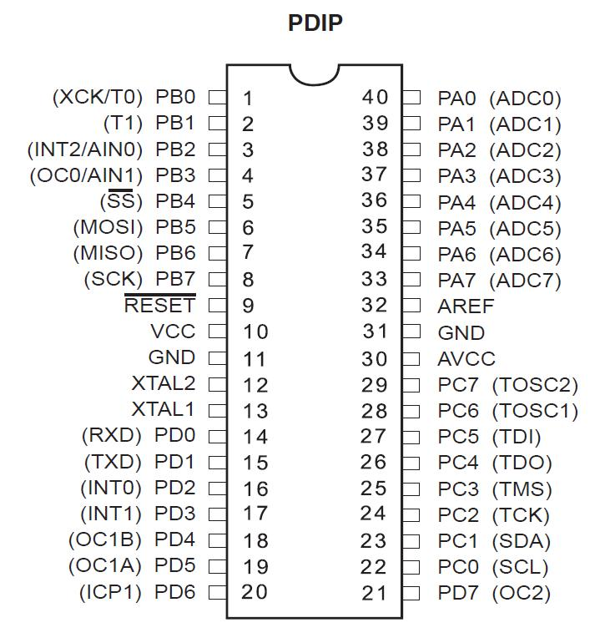

Analog comparator: On-chip analog comparator is available. An interrupt is assigned for different comparison result obtained from the inputs.
External Interrupt: 3External interrupt is accepted. Interrupt sense is configurable.
Memory: It has 32Kbytes of In-System Self-programmable Flash program memory, 1024 Bytes EEPROM, 2Kbytes Internal SRAM. Write/Erase Cycles: 10,000 Flash / 100,000 EEPROM.
Clock: It can run at a frequency from 1 to 16 MHz. Frequency can be obtained from external Quartz Crystal, Ceramic crystal or an R-C network. Internal calibrated RC oscillator can also be used.
More Features: Up to 16 MIPS throughput at 16MHz. Most of the instruction executes in a single cycle. Two cycle on-chip multiplication. 32 × 8 General Purpose Working Registers
Debug: JTAG boundary scan facilitates on chip debug.
Programming: Atmega32 can be programmed either by In-System Programming via Serial peripheral interface or by Parallel programming. Programming via JTAG interface is also possible. Programmer must ensure that SPI programming and JTAG are not be disabled using fuse bits; if the programming is supposed to be done using SPI or JTAG.

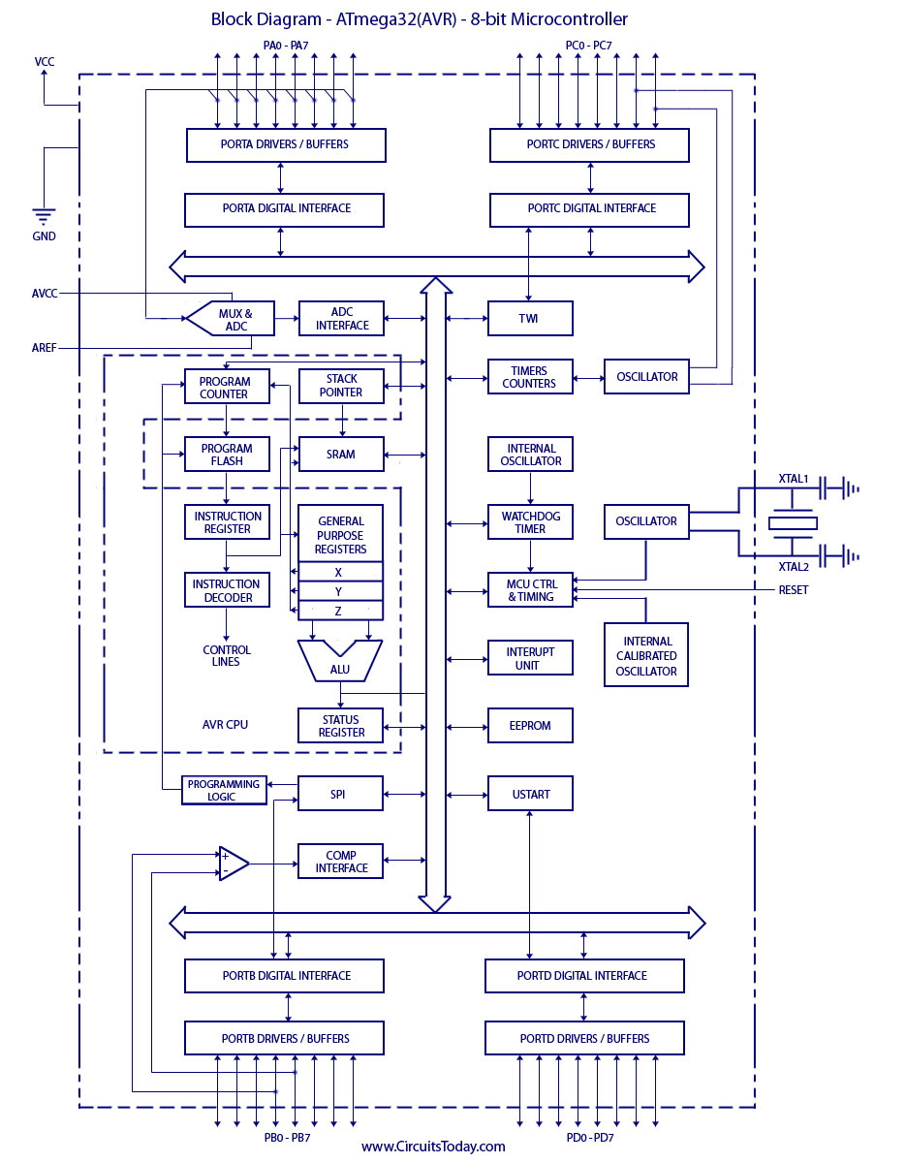

Buzzer

Table of Contents
Table of Contents 1
Buzzer 2
1. Introduction: 2
2. Buzzer Interfacing: 2

Buzzer

introduction:
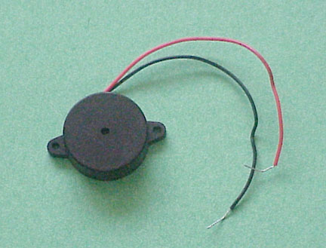
A buzzer or beeper is an audio signaling device, which may be mechanical, electromechanical, or piezoelectric. Typical uses of buzzers and beepers include alarm devices, timers and confirmation of user input such as a mouse click or keystroke.
Mechanical
A joy buzzer is an example of a purely mechanical buzzer.
Electro-mechanical
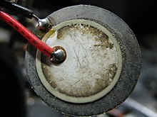
Early devices were based on an electromechanical system identical to an electric bell without the metal gong. Similarly, a relay may be connected to interrupt its own actuating current, causing the contacts to buzz. Often these units were anchored to a wall or ceiling to use it as a sounding board. The word "buzzer" comes from the rasping noise that electromechanical buzzers made.
Piezoelectric
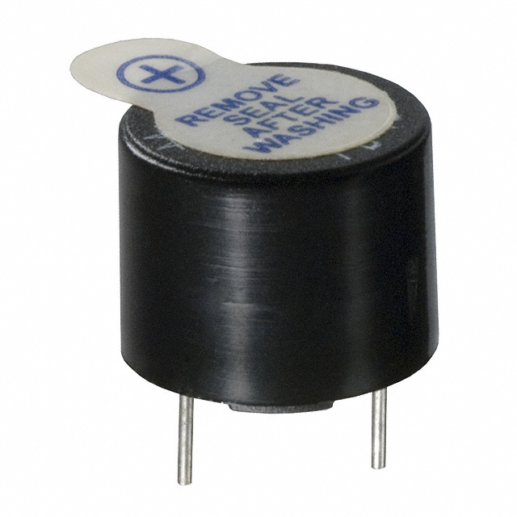
A piezoelectric element may be driven by an oscillating electronic circuit or other audio signal source, driven with a piezoelectric audio amplifier. Sounds commonly used to indicate that a button has been pressed are a click, a ring or a beep.

BUZZER interfacing:
If the proper potential is provided across the buzzer it generates the sound else not. It is of two pin configuration that is anode (+) and cathode (-). For interfacing to any device like controller etc. we directly connect the cathode to the GND and anode to the device like controller .Now when signal on anode goes high buzzer activates else does-not. Vice-versa is also true.

Non-Contact Infrared Temperature Sensor Module

The an infrared thermometer for non-contact temperature measurements. Both the IR sensitive thermopile detector chip and the signal conditioning ASIC are integrated in the same TO-39 can. Integrated into the MLX90614 are a low noise amplifier, 17-bit ADC and powerful DSP unit thus achieving high accuracy and resolution of the thermometer.
The thermometer comes factory calibrated with a digital SMBus output giving full access to the measured temperature in the complete temperature range(s) with a resolution of 0.02°C.
The user can configure the digital output to be pulse width modulation (PWM). As a standard, the 10-bit PWM is configured to continuously transmit the measured temperature in range of -20 to 120°C, with an output resolution of 0.14°C.

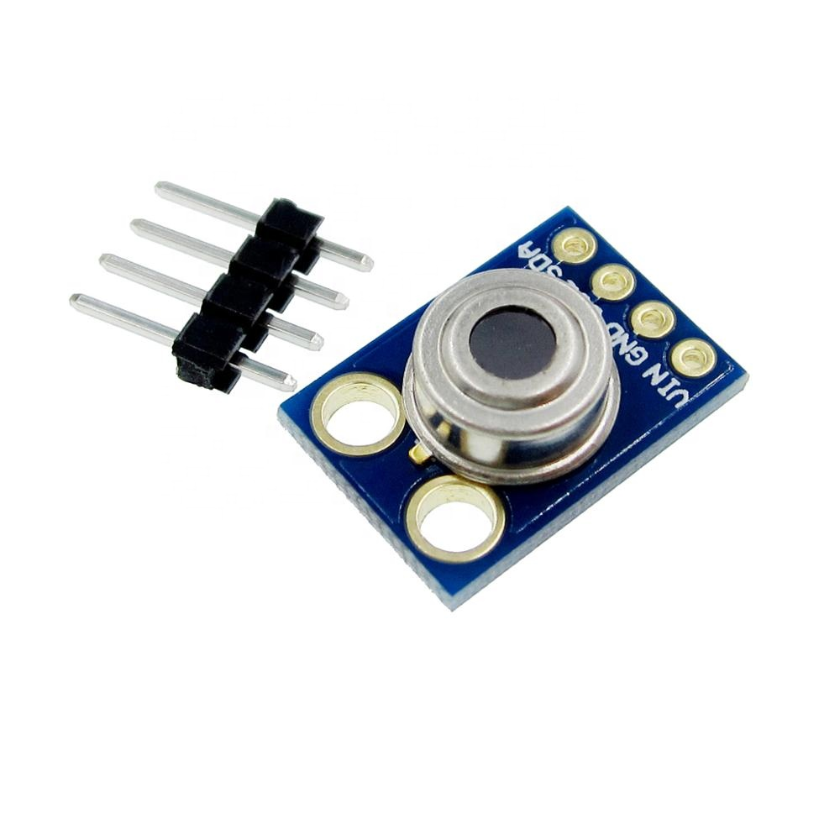

Mini Laser Dot Diode

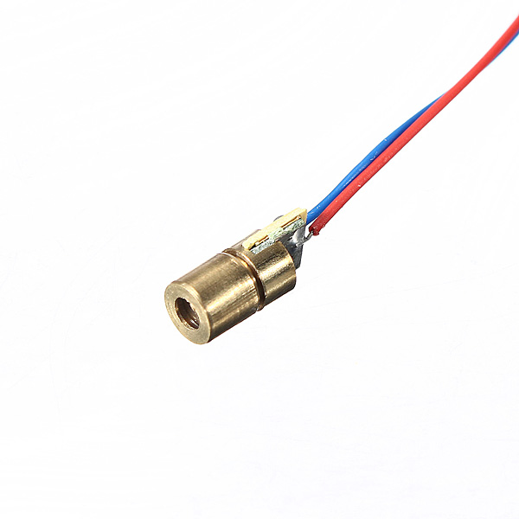
- Output Power: 5mW
- Working Voltage: 5V DC
- Working temperature: -10 ℃~＋40 ℃
- Housing material: Copper
- Working life: more than 2000 hours
- Spot mode: Dot Facula (continuous output)
- Laser wavelength: 650nm red-colored.
- Operating current: <40mA
- Power lead length: 120mm.

LED
A light-emitting diode (LED) is a semiconductor light source. LEDs are used as indicator lamps in many devices, and are increasingly used for lighting. When a light-emitting diode is forward biased (switched on), electrons are able to recombine with holes within the device, releasing energy in the form of photons.
This effect is called electroluminescence and the color of the light (corresponding to the energy of the photon) is determined by the energy gap of the semiconductor. An LED is often small in area (less than 1 mm²), and integrated optical components may be used to shape its radiation pattern. LEDs present many advantages over incandescent light sources including lower energy consumption, longer lifetime, improved robustness, smaller size, faster switching, and greater durability and reliability.

Types of LED’S 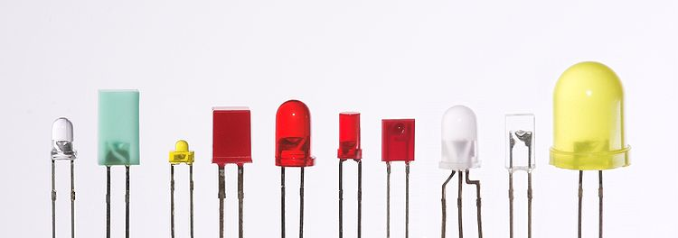
Fig 4.8(a): Types of LED

Light-emitting diodes are used in applications as diverse as replacements for aviation lighting, automotive lighting as well as in traffic signals. The compact size, the possibility of narrow bandwidth, switching speed, and extreme reliability of LEDs has allowed new text and video displays and sensors to be developed, while their high switching rates are also useful in advanced communications technology.
Electronic Symbol:
Fig
4.8(b): symbol of LED

White LED’S

Light Emitting Diodes (LED) have recently become available that are both white and bright, so bright that they seriously compete with incandescent lamps in lighting applications. They are still pretty expensive as compared to a GOW lamp but draw much less current and project a fairly well focused beam.

When run within their ratings, they are more reliable than lamps as well. Red LEDs are now being used in automotive and truck tail lights and in red traffic signal lights. You will be able to detect them because they look like an array of point sources and they go on and off instantly as compared to conventional incandescent lamps.

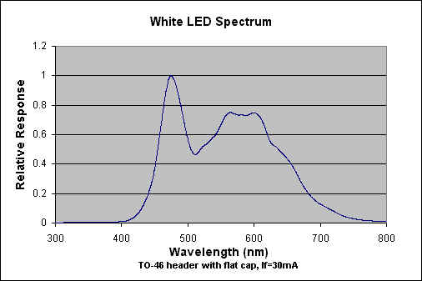

Fig 4.8(c): White LED spectrum

IN4007

Diodes are used to convert AC into DC these are used as half wave rectifier or full wave rectifier. Three points must he kept in mind while using any type of diode.
- Maximum forward current capacity
- Maximum reverse voltage capacity
- Maximum forward voltage capacity

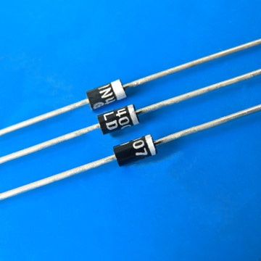
Fig: 1N4007 diodes
The number and voltage capacity of some of the important diodes available in the market are as follows:
- Diodes of number IN4001, IN4002, IN4003, IN4004, IN4005, IN4006 and IN4007 have maximum reverse bias voltage capacity of 50V and maximum forward current capacity of 1 Amp.
- Diode of same capacities can be used in place of one another. Besides this diode of more capacity can be used in place of diode of low capacity but diode of low capacity cannot be used in place of diode of high capacity. For example, in place of IN4002; IN4001 or IN4007 can be used but IN4001 or IN4002 cannot be used in place of IN4007.The diode BY125made by company BEL is equivalent of diode from IN4001 to IN4003. BY 126 is equivalent to diodes IN4004 to 4006 and BY 127 is equivalent to diode IN4007.
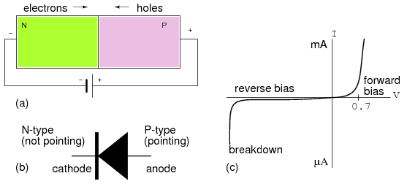
Fig:PN Junction diode

RESISTORS

A resistor is a two-terminal electronic component designed to oppose an electric current by producing a voltage drop between its terminals in proportion to the current, that is, in accordance with Ohm's law:
V = IR
Resistors are used as part of electrical networks and electronic circuits. They are extremely commonplace in most electronic equipment. Practical resistors can be made of various compounds and films, as well as resistance wire (wire made of a high-resistivity alloy, such as nickel/chrome).
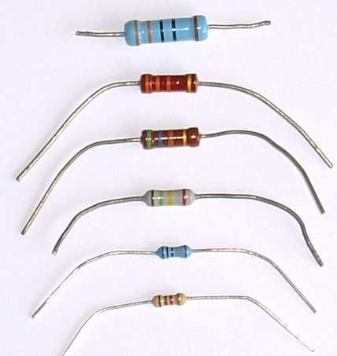
The primary characteristics of resistors are their resistance and the power they can dissipate. Other characteristics include temperature coefficient, noise, and inductance. Less well-known is critical resistance, the value below which power dissipation limits the maximum permitted current flow, and above which the limit is applied voltage. Critical resistance depends upon the materials constituting the resistor as well as its physical dimensions; it's determined by design.
Resistors can be integrated into hybrid and printed circuits, as well as integrated circuits. Size, and position of leads (or terminals) are relevant to equipment designers; resistors must be physically large enough not to overheat when dissipating their power.
A resistor is a two-terminal passive electronic component which implements electrical resistance as a circuit element. When a voltage V is applied across the terminals of a resistor, a current I will flow through the resistor in direct proportion to that voltage. The reciprocal of the constant of proportionality is known as the resistance R, since, with a given voltage V, a larger value of R further "resists" the flow of current I as given by Ohm's law:
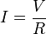
Resistors are common elements of electrical networks and electronic circuits and are ubiquitous in most electronic equipment. Practical resistors can be made of various compounds and films, as well as resistance wire (wire made of a high-resistivity alloy, such as nickel-chrome). Resistors are also implemented within integrated circuits, particularly analog devices, and can also be integrated into hybrid and printed circuits.
The electrical functionality of a resistor is specified by its resistance: common commercial resistors are manufactured over a range of more than 9 orders of magnitude. When specifying that resistance in an electronic design, the required precision of the resistance may require attention to the manufacturing tolerance of the chosen resistor, according to its specific application. The temperature coefficient of the resistance may also be of concern in some precision applications. Practical resistors are also specified as having a maximum power rating which must exceed the anticipated power dissipation of that resistor in a particular circuit: this is mainly of concern in power electronics applications. Resistors with higher power ratings are physically larger and may require heat sinking. In a high voltage circuit, attention must sometimes be paid to the rated maximum working voltage of the resistor.
The series inductance of a practical resistor causes its behaviour to depart from ohms law; this specification can be important in some high-frequency applications for smaller values of resistance. In a low-noise amplifier or pre-amp the noise characteristics of a resistor may be an issue. The unwanted inductance, excess noise, and temperature coefficient are mainly dependent on the technology used in manufacturing the resistor. They are not normally specified individually for a particular family of resistors manufactured using a particular technology. A family of discrete resistors is also characterized according to its form factor, that is, the size of the device and position of its leads (or terminals) which is relevant in the practical manufacturing of circuits using them.

Units
The ohm (symbol: Ω) is the SI unit of electrical resistance, named after Georg Simon Ohm. An ohm is equivalent to a volt per ampere. Since resistors are specified and manufactured over a very large range of values, the derived units of milliohm (1 mΩ = 10⁻³ Ω), kilohm (1 kΩ = 10³ Ω), and megohm (1 MΩ = 10⁶ Ω) are also in common usage.
The reciprocal of resistance R is called conductance G = 1/R and is measured in Siemens (SI unit), sometimes referred to as a mho. Thus a Siemens is the reciprocal of an ohm: S = Ω ⁻ ¹. Although the concept of conductance is often used in circuit analysis, practical resistors are always specified in terms of their resistance (ohms) rather than conductance.

Theory of operation

Ohm's law
The behaviour of an ideal resistor is dictated by the relationship specified in Ohm's law:
Ohm's law states that the voltage (V) across a resistor is proportional to the current (I) passing through it, where the constant of proportionality is the resistance (R).
Equivalently, Ohm's law can be stated:

This formulation of Ohm's law states that, when a voltage (V) is present across a resistance (R), a current (I) will flow through the resistance. This is directly used in practical computations. For example, if a 300 ohm resistor is attached across the terminals of a 12 volt battery, then a current of 12 / 300 = 0.04 amperes (or 40 mill amperes) will flow through that resistor.

Series and parallel resistors
In a series configuration, the current through all of the resistors is the same, but the voltage across each resistor will be in proportion to its resistance. The potential difference (voltage) seen across the network is the sum of those voltages, thus the total resistance can be found as the sum of those resistances:
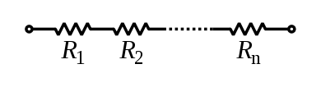
As a special case, the resistance of N resistors connected in series, each of the same resistance R, is given by NR.
Resistors in a parallel configuration are each subject to the same potential difference (voltage), however the currents through them add. The conductance of the resistors then add to determine the conductance of the network. Thus the equivalent resistance (R_{eq}) of the network can be computed:
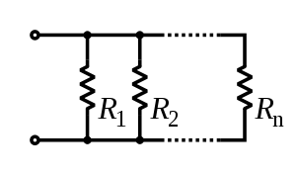
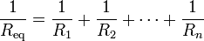
The parallel equivalent resistance can be represented in equations by two vertical lines "||" (as in geometry) as a simplified notation. For the case of two resistors in parallel, this can be calculated using:
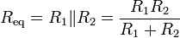
As a special case, the resistance of N resistors connected in parallel, each of the same resistance R, is given by R/N.
A resistor network that is a combination of parallel and series connections can be broken up into smaller parts that are either one or the other. For instance,
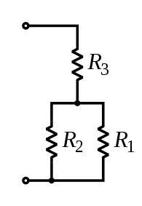
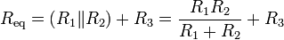
However, some complex networks of resistors cannot be resolved in this manner, requiring more sophisticated circuit analysis. For instance, consider a cube, each edge of which has been replaced by a resistor. What then is the resistance that would be measured between two opposite vertices? In the case of 12 equivalent resistors, it can be shown that the corner-to-corner resistance is ⁵⁄₆ of the individual resistance. More generally, the Y-Δ transform, or matrix methods can be used to solve such a problem. One practical application of these relationships is that a non-standard value of resistance can generally be synthesized by connecting a number of standard values in series and/or parallel. This can also be used to obtain a resistance with a higher power rating than that of the individual resistors used. In the special case of N identical resistors all connected in series or all connected in parallel, the power rating of the individual resistors is thereby multiplied by N.

CAPACITORS

A capacitor or condenser is a passive electronic component consisting of a pair of conductors separated by a dielectric. When a voltage potential difference exists between the conductors, an electric field is present in the dielectric. This field stores energy and produces a mechanical force between the plates. The effect is greatest between wide, flat, parallel, narrowly separated conductors.
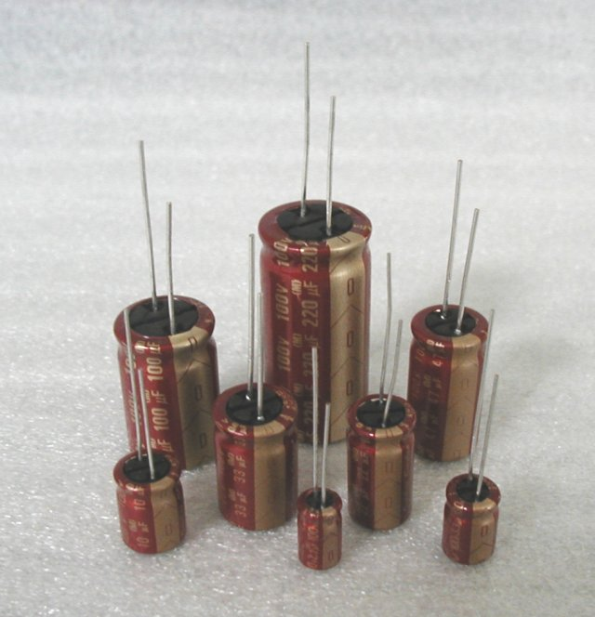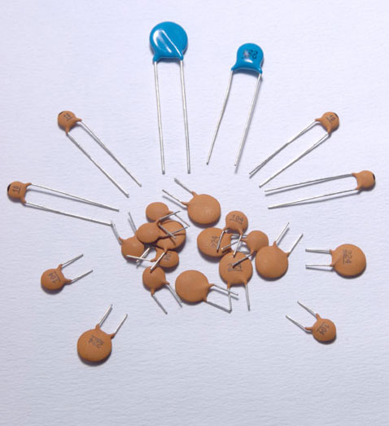

An ideal capacitor is characterized by a single constant value, capacitance, which is measured in farads. This is the ratio of the electric charge on each conductor to the potential difference between them. In practice, the dielectric between the plates passes a small amount of leakage current. The conductors and leads introduce an equivalent series resistance and the dielectric has an electric field strength limit resulting in a breakdown voltage.
The properties of capacitors in a circuit may determine the resonant frequency and quality factor of a resonant circuit, power dissipation and operating frequency in a digital logic circuit, energy capacity in a high-power system, and many other important aspects.
A capacitor (formerly known as condenser) is a device for storing electric charge. The forms of practical capacitors vary widely, but all contain at least two conductors separated by a non-conductor. Capacitors used as parts of electrical systems, for example, consist of metal foils separated by a layer of insulating film.
Capacitors are widely used in electronic circuits for blocking direct current while allowing alternating current to pass, in filter networks, for smoothing the output of power supplies, in the resonant circuits that tune radios to particular frequencies and for many other purposes.
A capacitor is a passive electronic component consisting of a pair of conductors separated by a dielectric (insulator). When there is a potential difference (voltage) across the conductors, a static electric field develops in the dielectric that stores energy and produces a mechanical force between the conductors. An ideal capacitor is characterized by a single constant value, capacitance, measured in farads. This is the ratio of the electric charge on each conductor to the potential difference between them.
The capacitance is greatest when there is a narrow separation between large areas of conductor, hence capacitor conductors are often called "plates", referring to an early means of construction. In practice the dielectric between the plates passes a small amount of leakage current and also has an electric field strength limit, resulting in a breakdown voltage, while the conductors and leads introduce an undesired inductance and resistance.
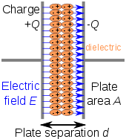

Parallel plate model
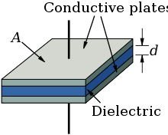
Dielectric is placed between two conducting plates, each of area A and with a separation of d.
The simplest capacitor consists of two parallel conductive plates separated by a dielectric with permittivity ε (such as air). The model may also be used to make qualitative predictions for other device geometries. The plates are considered to extend uniformly over an area A and a charge density ±ρ = ±Q/A exists on their surface. Assuming that the width of the plates is much greater than their separation d, the electric field near the centre of the device will be uniform with the magnitude E = ρ/ε. The voltage is defined as the line integral of the electric field between the plates
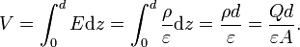
Solving this for C = Q/V reveals that capacitance increases with area and decreases with separation
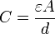.
The capacitance is therefore greatest in devices made from materials with a high permittivity.
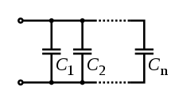
Several capacitors in parallel

PUSH BUTTONS

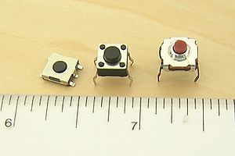

A push-button (also spelled pushbutton) or simply button is a simple switch mechanism for controlling some aspect of a machine or a process. Buttons are typically made out of hard material, usually plastic or metal. The surface is usually flat or shaped to accommodate the human finger or hand, so as to be easily depressed or pushed. Buttons are most often biased switches, though even many un-biased buttons (due to their physical nature) require a spring to return to their un-pushed state. Different people use different terms for the "pushing" of the button, such as press, depress, mash, and punch.

Uses:
In industrial and commercial applications push buttons can be linked together by a mechanical linkage so that the act of pushing one button causes the other button to be released. In this way, a stop button can "force" a start button to be released. This method of linkage is used in simple manual operations in which the machine or process have no electrical circuits for control.
Pushbuttons are often color-coded to associate them with their function so that the operator will not push the wrong button in error. Commonly used colors are red for stopping the machine or process and green for starting the machine or process.
Red pushbuttons can also have large heads (mushroom shaped) for easy operation and to facilitate the stopping of a machine. These pushbuttons are called emergency stop buttons and are mandated by the electrical code in many jurisdictions for increased safety. This large mushroom shape can also be found in buttons for use with operators who need to wear gloves for their work and could not actuate a regular flush-mounted push button. As an aid for operators and users in industrial or commercial applications, a pilot light is commonly added to draw the attention of the user and to provide feedback if the button is pushed. Typically this light is included into the center of the pushbutton and a lens replaces the pushbutton hard center disk.
The source of the energy to illuminate the light is not directly tied to the contacts on the back of the pushbutton but to the action the pushbutton controls. In this way a start button when pushed will cause the process or machine operation to be started and a secondary contact designed into the operation or process will close to turn on the pilot light and signify the action of pushing the button caused the resultant process or action to start.
In popular culture, the phrase "the button" refers to a (usually fictional) button that a military or government leader could press to launch nuclear weapons.

Push to ON button:
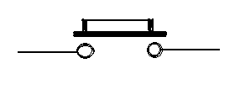
Fig 4.3(a): push on button
Initially the two contacts of the button are open. When the button is pressed they become connected. This makes the switching operation using the push button.

Arduino
Arduino is an open-source prototyping platform based on easy-to-use hardware and software. Arduino boards are able to read inputs - light on a sensor, a finger on a button, or a Twitter message - and turn it into an output - activating a motor, turning on an LED, publishing something online. You can tell your board what to do by sending a set of instructions to the microcontroller on the board. To do so you use the Arduino programming language (based onWiring), and the Arduino Software (IDE), based on Processing.
Over the years Arduino has been the brain of thousands of projects, from everyday objects to complex scientific instruments. A worldwide community of makers - students, hobbyists, artists, programmers, and professionals - has gathered around this open-source platform, their contributions have added up to an incredible amount of accessible knowledge that can be of great help to novices and experts alike.
Arduino was born at the Ivrea Interaction Design Institute as an easy tool for fast prototyping, aimed at students without a background in electronics and programming. As soon as it reached a wider community, the Arduino board started changing to adapt to new needs and challenges, differentiating its offer from simple 8-bit boards to products for IoT applications, wearable, 3D printing, and embedded environments. All Arduino boards are completely open-source, empowering users to build them independently and eventually adapt them to their particular needs. The software, too, is open-source, and it is growing through the contributions of users worldwide.

Why Arduino?
Thanks to its simple and accessible user experience, Arduino has been used in thousands of different projects and applications. The Arduino software is easy-to-use for beginners, yet flexible enough for advanced users. It runs on Mac, Windows, and Linux. Teachers and students use it to build low cost scientific instruments, to prove chemistry and physics principles, or to get started with programming and robotics. Designers and architects build interactive prototypes, musicians and artists use it for installations and to experiment with new musical instruments. Makers, of course, use it to build many of the projects exhibited at the Maker Faire, for example. Arduino is a key tool to learn new things. Anyone - children, hobbyists, artists, programmers - can start tinkering just following the step by step instructions of a kit, or sharing ideas online with other members of the Arduino community.
There are many other microcontrollers and microcontroller platforms available for physical computing. Parallax Basic Stamp, Netmedia's BX-24, Phidgets, MIT's Handyboard, and many others offer similar functionality. All of these tools take the messy details of microcontroller programming and wrap it up in an easy-to-use package. Arduino also simplifies the process of working with microcontrollers, but it offers some advantage for teachers, students, and interested amateurs over other systems:
- Inexpensive - Arduino boards are relatively inexpensive compared to other microcontroller platforms. The least expensive version of the Arduino module can be assembled by hand, and even the pre-assembled Arduino modules cost less than $50
- Cross-platform - The Arduino Software (IDE) runs on Windows, Macintosh OSX, and Linux operating systems. Most microcontroller systems are limited to Windows.
- Simple, clear programming environment - The Arduino Software (IDE) is easy-to-use for beginners, yet flexible enough for advanced users to take advantage of as well. For teachers, it's conveniently based on the Processing programming environment, so students learning to program in that environment will be familiar with how the Arduino IDE works.
- Open source and extensible software - The Arduino software is published as open source tools, available for extension by experienced programmers. The language can be expanded through C++ libraries, and people wanting to understand the technical details can make the leap from Arduino to the AVR C programming language on which it's based. Similarly, you can add AVR-C code directly into your Arduino programs if you want to.
- Open source and extensible hardware - The plans of the Arduino boards are published under a Creative Commons license, so experienced circuit designers can make their own version of the module, extending it and improving it. Even relatively inexperienced users can build the breadboard version of the module in order to understand how it works and save money.

Arduino Uno
The most common version of Arduino is the Arduino Uno. This board is what most people are talking about when they refer to an Arduino. In the next step, there is a more complete rundown of its features.
Arduino NG, Diecimila, and the Duemilanove (Legacy Versions)
Legacy versions of the Arduino Uno product line consist of the NG, Diecimila, and the Duemilanove. The important thing to note about legacy boards is that they lack particular feature of the Arduino Uno. Some key differences:
- The Diecimila and NG use an ATMEGA168 chips (as opposed to the more powerful ATMEGA328),
- Both the Diecimila and NG have a jumper next to the USB port and require manual selection of either USB or battery power.
- The Arduino NG requires that you hold the rest button on the board for a few seconds prior to uploading a program.
Arduino Mega 2560
The Mega is the second most commonly encountered version of the Arduino family. The Arduino Mega is like the Arduino Uno's beefier older brother. It boasts 256 KB of memory (8 times more than the Uno). It also had 54 input and output pins, 16 of which are analog pins, and 14 of which can do PWM. However, all of the added functionality comes at the cost of a slightly larger circuit board. It may make your project more powerful, but it will also make your project larger. Check out the official Arduino Mega 2560 page for more details.
Arduino Mega ADK
This specialized version of the Arduino is basically an Arduino Mega that has been specifically designed for interfacing with Android smartphones.
Arduino LilyPad
The LilyPad was designed for wearable and e-textile applications. It is intended to be sewn to fabric and connected to other sewable components using conductive thread. This board requires the use of a special FTDI-USB TTL serial programming cable. For more information, the Arduino LilyPad page is a decent starting point.

Some people think of the entire Arduino board as a microcontroller, but this is inaccurate. The Arduino board actually is a specially designed circuit board for programming and prototyping with Atmel microcontrollers.
The nice thing about the Arduino board is that it is relatively cheap, plugs straight into a computer's USB port, and it is dead-simple to setup and use (compared to other development boards).
Some of the key features of the Arduino Uno include:
- An open source design. The advantage of it being open source is that it has a large community of people using and troubleshooting it. This makes it easy to find someone to help you debug your projects.
- An easy USB interface . The chip on the board plugs straight into your USB port and registers on your computer as a virtual serial port. This allows you to interface with it as through it were a serial device. The benefit of this setup is that serial communication is an extremely easy (and time-tested) protocol, and USB makes connecting it to modern computers really convenient.
- Very convenient power management and built-in voltage regulation. You can connect an external power source of up to 12v and it will regulate it to both 5v and 3.3v. It also can be powered directly off of a USB port without any external power.
- An easy-to-find, and dirt cheap, microcontroller "brain." The ATmega328 chip retails for about $2.88 on Digikey. It has countless number of nice hardware features like timers, PWM pins, external and internal interrupts, and multiple sleep modes. Check out the official datasheet for more details.
- A 16mhz clock. This makes it not the speediest microcontroller around, but fast enough for most applications.
- 32 KB of flash memory for storing your code.
- 13 digital pins and 6 analog pins. These pins allow you to connect external hardware to your Arduino. These pins are key for extending the computing capability of the Arduino into the real world. Simply plug your devices and sensors into the sockets that correspond to each of these pins and you are good to go.
- An ICSP connector for bypassing the USB port and interfacing the Arduino directly as a serial device. This port is necessary to re-bootload your chip if it corrupts and can no longer talk to your computer.
- An on-board LED attached to digital pin 13 for fast an easy debugging of code.
- And last, but not least, a button to reset the program on the chip.

6. SCHEMATIC DIAGRAM

6.1 DESCRIPTION
POWER SUPPLY
The circuit uses standard power supply comprising of a step-down transformer from 230Vto 12V and 4 diodes forming a bridge rectifier that delivers pulsating dc which is then filtered by an electrolytic capacitor of about 470µF to 1000µF. The filtered dc being unregulated, IC LM7805 is used to get 5V DC constant at its pin no 3 irrespective of input DC varying from 7V to 15V. The input dc shall be varying in the event of input ac at 230volts section varies from 160V to 270V in the ratio of the transformer primary voltage V1 to secondary voltage V2 governed by the formula V1/V2=N1/N2. As N1/N2 i.e. no. of turns in the primary to the no. of turns in the secondary remains unchanged V2 is directly proportional to V1.Thus if the transformer delivers 12V at 220V input it will give 8.72V at 160V.Similarly at 270V it will give 14.72V.Thus the dc voltage at the input of the regulator changes from about 8V to 15V because of A.C voltage variation from 160V to 270V the regulator output will remain constant at 5V.
The regulated 5V DC is further filtered by a small electrolytic capacitor of 10µF for any noise so generated by the circuit. One LED is connected of this 5V point in series with a current limiting resistor of 330Ω to the ground i.e., negative voltage to indicate 5V power supply availability. The unregulated 12V point is used for other applications as and when required.

CODING

Arduino IDE

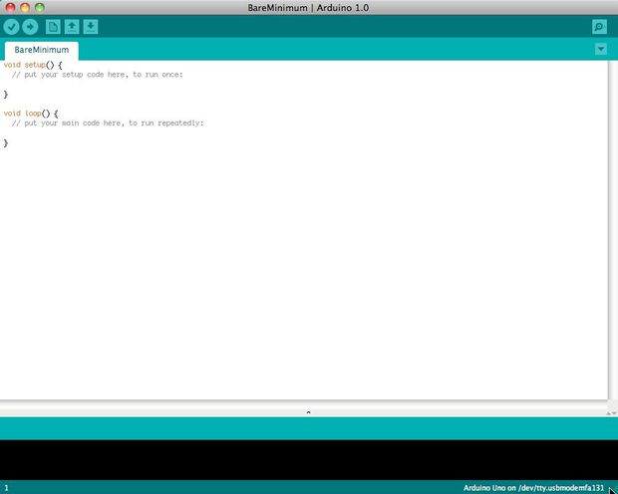

Before you can start doing anything with the Arduino, you need to download and install the Arduino IDE (integrated development environment). From this point on we will be referring to the Arduino IDE as the Arduino Programmer.
The Arduino Programmer is based on the Processing IDE and uses a variation of the C and C++ programming languages.

Settings

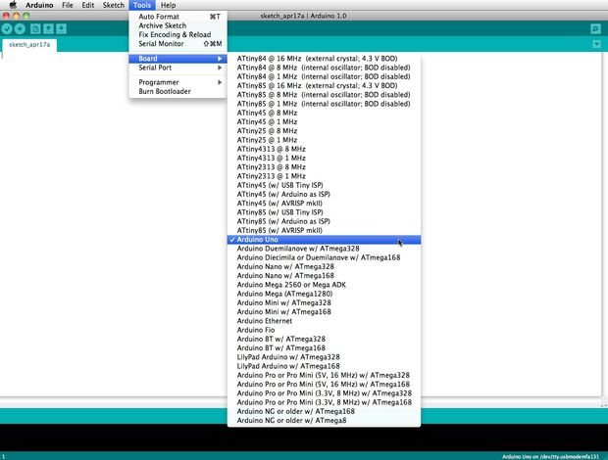

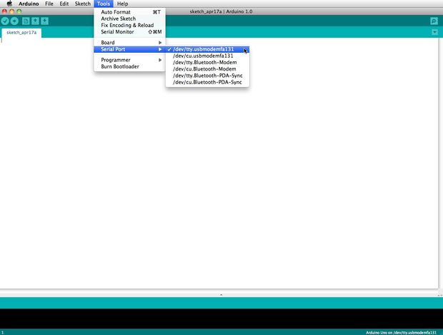

Before you can start doing anything in the Arduino programmer, you must set the board-type and serial port.
To set the board, go to the following:
Tools --> Boards
Select the version of board that you are using. Since I have an Arduino Uno plugged in, I obviously selected "Arduino Uno."
To set the serial port, go to the following:
Tools --> Serial Port
Select the serial port that looks like:
/dev/tty.usbmodem [random numbers]

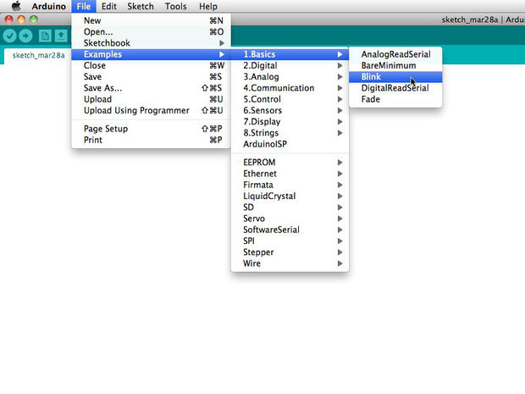

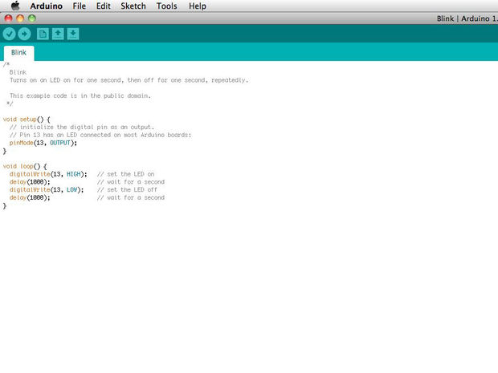

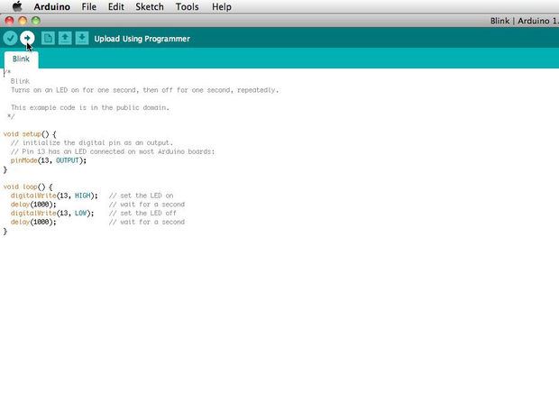

Arduino programs are called sketches. The Arduino programmer comes with a ton of example sketches preloaded. This is great because even if you have never programmed anything in your life, you can load one of these sketches and get the Arduino to do something.
To get the LED tied to digital pin 13 to blink on and off, let's load the blink example.
The blink example can be found here:
Files --> Examples --> Basics --> Blink

The blink example basically sets pin D13 as an output and then blinks the test LED on the Arduino board on and off every second.
Once the blink example is open, it can be installed onto the ATMEGA328 chip by pressing the upload button, which looks like an arrow pointing to the right.
Notice that the surface mount status LED connected to pin 13 on the Arduino will start to blink. You can change the rate of the blinking by changing the length of the delay and pressing the upload button again.

Serial monitor

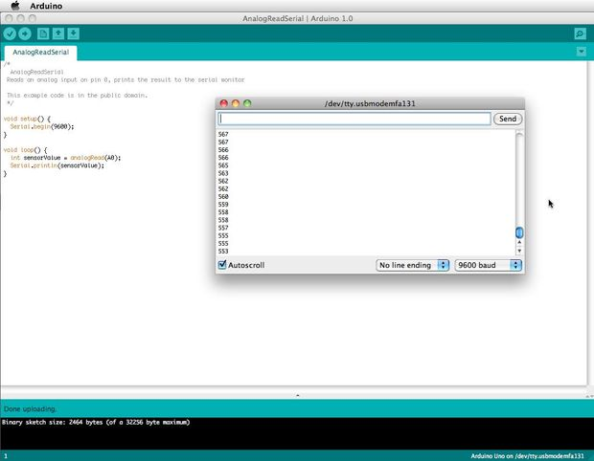

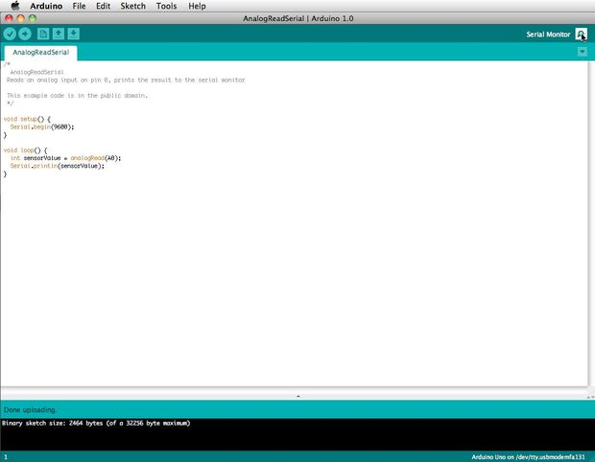

The serial monitor allows your computer to connect serially with the Arduino. This is important because it takes data that your Arduino is receiving from sensors and other devices and displays it in real-time on your computer. Having this ability is invaluable to debug your code and understand what number values the chip is actually receiving.
For instance, connect center sweep (middle pin) of a potentiometer to A0, and the outer pins, respectively, to 5v and ground. Next upload the sketch shown below:
File --> Examples --> 1.Basics --> AnalogReadSerial

Click the button to engage the serial monitor which looks like a magnifying glass. You can now see the numbers being read by the analog pin in the serial monitor. When you turn the knob the numbers will increase and decrease.
The numbers will be between the range of 0 and 1023. The reason for this is that the analog pin is converting a voltage between 0 and 5V to a discreet number.

The Arduino has two different types of input pins, those being analog and digital.
To begin with, lets look at the digital input pins.
Digital input pins only have two possible states, which are on or off. These two on and off states are also referred to as:
- HIGH or LOW
- 1 or 0
- 5V or 0V.
This input is commonly used to sense the presence of voltage when a switch is opened or closed.
Digital inputs can also be used as the basis for countless digital communication protocols. By creating a 5V (HIGH) pulse or 0V (LOW) pulse, you can create a binary signal, the basis of all computing. This is useful for talking to digital sensors like a PING ultrasonic sensor, or communicating with other devices.
For a simple example of a digital input in use, connect a switch from digital pin 2 to 5V, a 10K resistor** from digital pin 2 to ground, and run the following code:
File --> Examples --> 2.Digital --> Button

Analog in

Aside from the digital input pins, the Arduino also boasts a number of analog input pins.
Analog input pins take an analog signal and perform a 10-bit analog-to-digital (ADC) conversion to turn it into a number between 0 and 1023 (4.9mV steps).
This type of input is good for reading resistive sensors. These are basically sensors which provide resistance to the circuit. They are also good for reading a varying voltage signal between 0 and 5V. This is useful when interfacing with various types of analog circuitry.

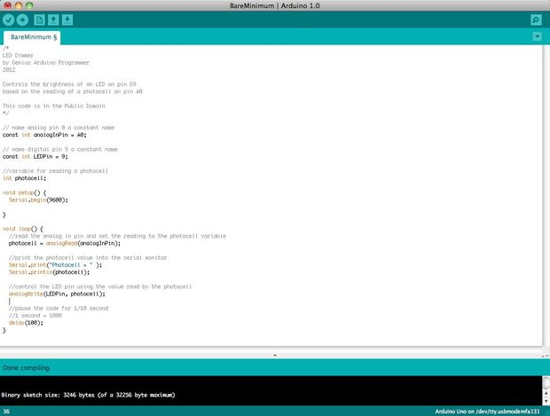

To write your own code, you will need to learn some basic programming language syntax. In other words, you have to learn how to properly form the code for the programmer to understand it. You can think of this kind of like understanding grammar and punctuation. You can write an entire book without proper grammar and punctuation, but no one will be abler to understand it, even if it is in English.
Some important things to keep in mind when writing your own code:
- An Arduino program is called a sketch.
- All code in an Arduino sketch is processed from top to bottom.
- Arduino sketches are typically broken into five parts.
- The sketch usually starts with a header that explains what the sketch is doing, and who wrote it.
- Next, it usually defines global variables. Often, this is where constant names are given to the different Arduino pins.
- After the initial variables are set, the Arduino begins the setup routine. In the setup function, we set initial conditions of variables when necessary, and run any preliminary code that we only want to run once. This is where serial communication is initiated, which is required for running the serial monitor.
- From the setup function, we go to the loop routine. This is the main routine of the sketch. This is not only where your main code goes, but it will be executed over and over, so long as the sketch continues to run.
- Below the loop routine, there is often other functions listed. These functions are user-defined and only activated when called in the setup and loop routine. When these functions are called, the Arduino processes all of the code in the function from top to bottom and then goes back to the next line in the sketch where it left off when the function was called. Functions are good because they allow you to run standard routines - over and over - without having to write the same lines of code over and over. You can simply call upon a function multiple times, and this will free up memory on the chip because the function routine is only written once. It also makes code easier to read. To learn how to form your own functions, check outthis page.
- All of that said, the only two parts of the sketch which are mandatory are the Setup and Loop routines.
- Code must be written in the Arduino Language, which is roughly based on C.
- Almost all statements written in the Arduino language must end with a ;
- Conditionals (such as if statements and for loops) do not need a ;
- Conditionals have their own rules and can be found under "Control Structures" on the Arduino Language page
- Variables are storage compartments for numbers. You can pass values into and out of variables. Variables must be defined (stated in the code) before they can be used and need to have a data type associated with it. To learn some of the basic data types, review the Language Page.
Okay! So let us say we want to write code that reads a photocell connected to pin A0, and use the reading we get from the photocell to control the brightness of an LED connected to pin D9.
First, we want to open the BareMinimum sketch, which can be found at:
File --> Examples --> 1.Basic --> BareMinimum

The BareMinimum Sketch should look like this:

<pre>void setup() {
// put your setup code here, to run once:

}

void loop() {
// put your main code here, to run repeatedly:

}

Next, lets put a header on the code, so other people know about what we are making, why, and under what terms:

<pre>/*
LED Dimmer
by Genius Arduino Programmer
2012

Controls the brightness of an LED on pin D9
based on the reading of a photocell on pin A0

This code is in the Public Domain
*/

void setup() {
// put your setup code here, to run once:

}

void loop() {
// put your main code here, to run repeatedly:

}

Once that is all squared away, let us define the pin names, and establish variables:

<pre>/*
LED Dimmer
by Genius Arduino Programmer
2012

Controls the brightness of an LED on pin D9
based on the reading of a photocell on pin A0

This code is in the Public Domain
*/

// name analog pin 0 a constant name
const int analogInPin = A0;

// name digital pin 9 a constant name
const int LEDPin = 9;

//variable for reading a photocell
int photocell;

void setup() {
// put your setup code here, to run once:

}

void loop() {
// put your main code here, to run repeatedly:

}

Now that variables and pin names are set, let us write the actual code:
<pre>/*
LED Dimmer
by Genius Arduino Programmer
2012

Controls the brightness of an LED on pin D9
based on the reading of a photocell on pin A0

This code is in the Public Domain
*/

// name analog pin 0 a constant name
const int analogInPin = A0;

// name digital pin 9 a constant name
const int LEDPin = 9;

//variable for reading a photocell
int photocell;

void setup() {
//nothing here right now

}

void loop() {
//read the analog in pin and set the reading to the photocell variable
photocell = analogRead(analogInPin);

//control the LED pin using the value read by the photocell
analogWrite(LEDPin, photocell);

//pause the code for 1/10 second
//1 second = 1000
delay(100);
}

If we want to see what numbers the analog pin is actually reading from the photocell, we will need to use the serial monitor. Let's activate the serial port and output those numbers:
<pre>/*
LED Dimmer
by Genius Arduino Programmer
2012

Controls the brightness of an LED on pin D9
based on the reading of a photocell on pin A0

This code is in the Public Domain
*/

// name analog pin 0 a constant name
const int analogInPin = A0;

// name digital pin 9 a constant name
const int LEDPin = 9;

//variable for reading a photocell
int photocell;

void setup() {
Serial.begin(9600);

}

void loop() {
//read the analog in pin and set the reading to the photocell variable
photocell = analogRead(analogInPin);

//print the photocell value into the serial monitor
Serial.print("Photocell = " );
Serial.println(photocell);

//control the LED pin using the value read by the photocell
analogWrite(LEDPin, photocell);

//pause the code for 1/10 second
//1 second = 1000
delay(100);
}

10.HARDWARE TESTING

10.1 CONTINUITY TEST:
In electronics, a continuity test is the checking of an electric circuit to see if current flows (that it is in fact a complete circuit). A continuity test is performed by placing a small voltage (wired in series with an LED or noise-producing component such as a piezoelectric speaker) across the chosen path. If electron flow is inhibited by broken conductors, damaged components, or excessive resistance, the circuit is "open".
Devices that can be used to perform continuity tests include multi meters which measure current and specialized continuity testers which are cheaper, more basic devices, generally with a simple light bulb that lights up when current flows.
An important application is the continuity test of a bundle of wires so as to find the two ends belonging to a particular one of these wires; there will be a negligible resistance between the "right" ends, and only between the "right" ends.
This test is the performed just after the hardware soldering and configuration has been completed. This test aims at finding any electrical open paths in the circuit after the soldering. Many a times, the electrical continuity in the circuit is lost due to improper soldering, wrong and rough handling of the PCB, improper usage of the soldering iron, component failures and presence of bugs in the circuit diagram. We use a multi meter to perform this test. We keep the multi meter in buzzer mode and connect the ground terminal of the multi meter to the ground. We connect both the terminals across the path that needs to be checked. If there is continuation then you will hear the beep sound.

10.2 POWER ON TEST:
This test is performed to check whether the voltage at different terminals is according to the requirement or not. We take a multi meter and put it in voltage mode. Remember that this test is performed without microcontroller. Firstly, we check the output of the transformer, whether we get the required 12 v AC voltage.
Then we apply this voltage to the power supply circuit. Note that we do this test without microcontroller because if there is any excessive voltage, this may lead to damaging the controller. We check for the input to the voltage regulator i.e., are we getting an input of 12v and an output of 5v. This 5v output is given to the microcontrollers’ 40th pin. Hence we check for the voltage level at 40th pin. Similarly, we check for the other terminals for the required voltage. In this way we can assure that the voltage at all the terminals is as per the requirement.

BIBLIOGRAPHY
TEXT BOOKS REFERED
1. ATMEGA 328 Data Sheets.

WEBSITES
- www.atmel.com
- www.beyondlogic.org
- www.wikipedia.org
- www.howstuffworks.com
- www.alldatasheets.com

